Prompt:
You are an experienced Software Quality Engineer. Carefully analyze the attached SRS document and generate manual test cases that ensure coverage of both functional and non-functional requirements. Each test case should include:
- Module Name
- Test Case ID
- Test Objective
- Preconditions
- Test Steps
- Test Data
- Expected Result
- Priority (High/Medium/Low)
Make sure to cover positive, negative, and edge scenarios.
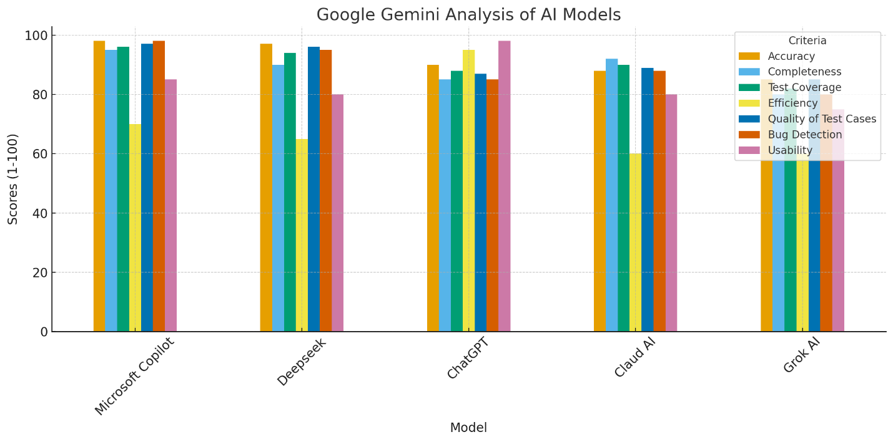
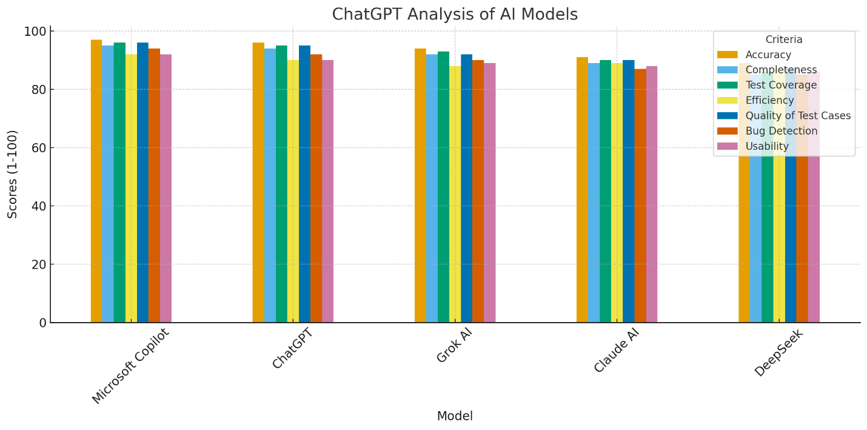
Manual Analysis
Based on my manual analysis, I would consider Microsoft Copilot as the first choice, followed by ChatGPT and Claude AI. Both Claude AI and ChatGPT provide well-structured test cases with detailed coverage of positive and negative scenarios. However, Microsoft Copilot stands out by offering superior coverage, excellent presentation, a well-defined format, and outputs that are easy to understand. For these reasons, I consider Copilot the winner, with ChatGPT and Claude AI sharing the second spot.
On the other hand, Grok AI and DeepSeek were the weakest performers, as their outputs lacked depth, consistency, and completeness compared to the other models.

